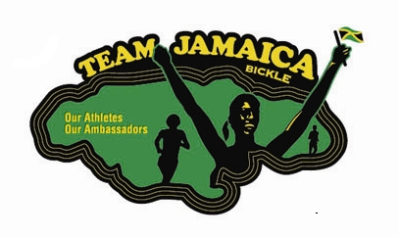
TEAM JAMAICA BICKLE, PHILADELPHIA
E-mail:
Dinner Dance
SATURDAY, August 22, 2020
(215) 680 - 0613
Bartley67b@hotmail.com

Greetings:

Team Jamaica Bickle, Philadelphia will be celebrating Jamaica’s Independence with a Celebration on Saturday, August 22, 2020 at the Hilton, City Avenue, located at 4200 City Avenue, Philadelphia, PA 19131. The Dinner Dance is also a fundraising activity for Team Jamaica Bickle, Philadelphia in preparation of hosting Jamaican athletes, as well as athletes from other Caribbean countries during the annual running of the Penn Relays in April of each year.

ABOUT TEAM JAMAICA BICKLE:
Team Jamaica Bickle is a non-profit organization that provides food and hospitality services for the visiting athletes and officials from Jamaica and the Caribbean who attend the annual Penn Relays. The group provides over 650 visiting athletes and coaches with food, transportation and accommodation in Philadelphia while the athletes participate in the Penn Relays.

Please complete the Ad Reservation Form below and return it with your camera-ready ad to Michele Bartley via email at bartley67b@hotmail.com or to Team Jamaica Bickle, Philadelphia, P.O. Box 15865, Philadelphia, PA 19103.
AD FEE SCHEDULE
BOOK SIZE 8 ½ X 11
Full Page ……………………………. $150
½ Page... .. $75
¼ Page……………………... …$50
Business Card .. …$25
Patron Page ………………………….. $5
InsideFront/InsideBack…………... $200
Back Cover(color)..………………. $300

Do not write below this line
Deadline: July 22, 2020
TEAM JAMAICA BICKLE, PHILADELPHIA AD RESERVATION FORM
Company/Organization:
Address:
City, State, Zip:
Telephone:
Contact Person(s):

Date received:
Copy enclosed:
Photo enclosed:
Prepared by:

